2.5 I can change the file formats of documents appropriately for content

I have been designing my header for my Chubu website page.

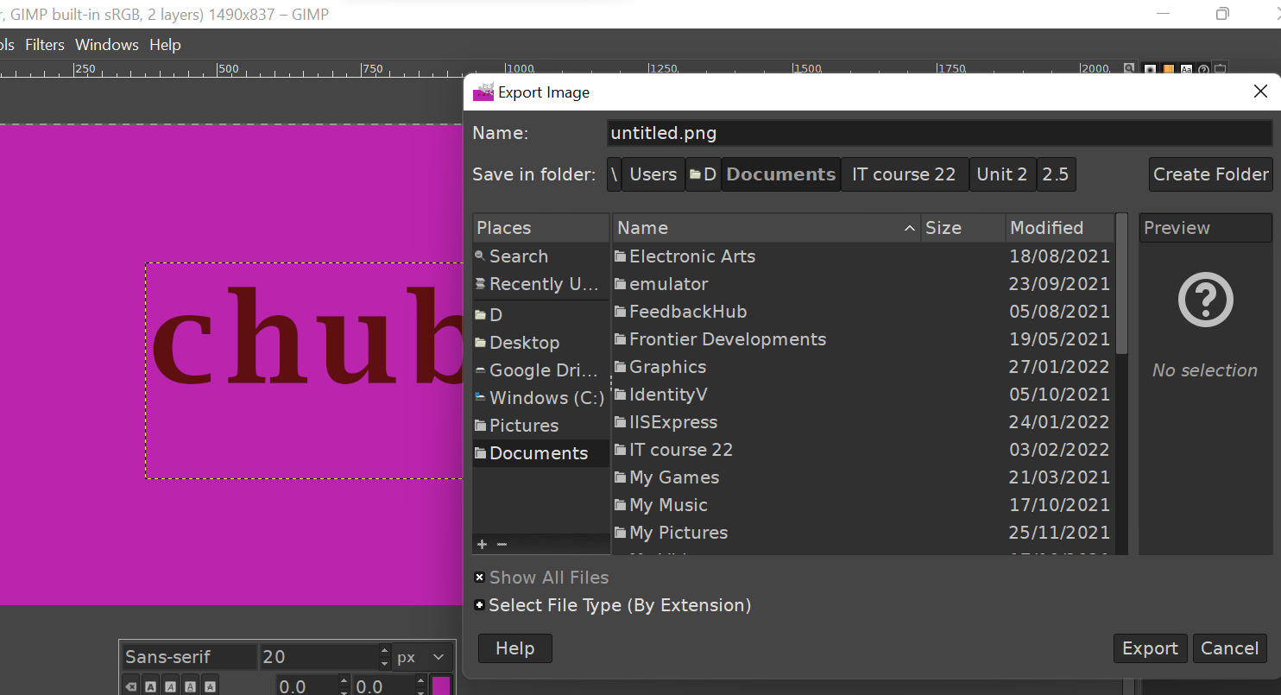

[The above image that I have made the header in Gimp and started to export the image but I have highlighted the file name]

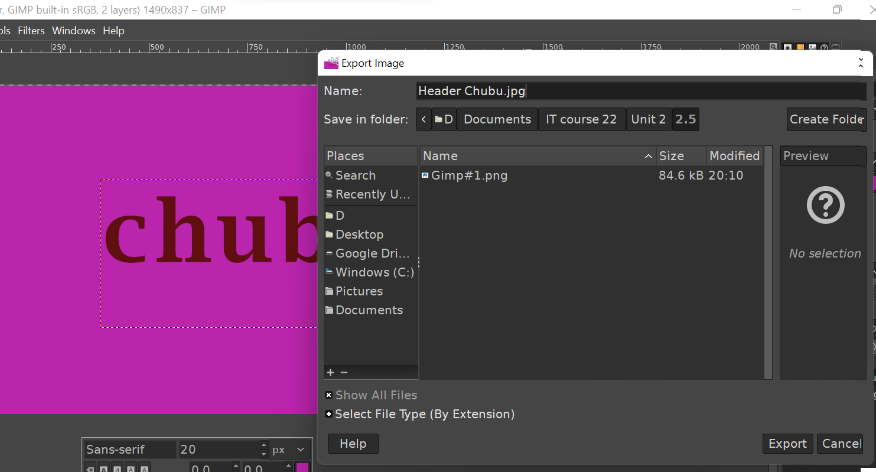

[The above image shows that I have gave it a .jpg file extension]

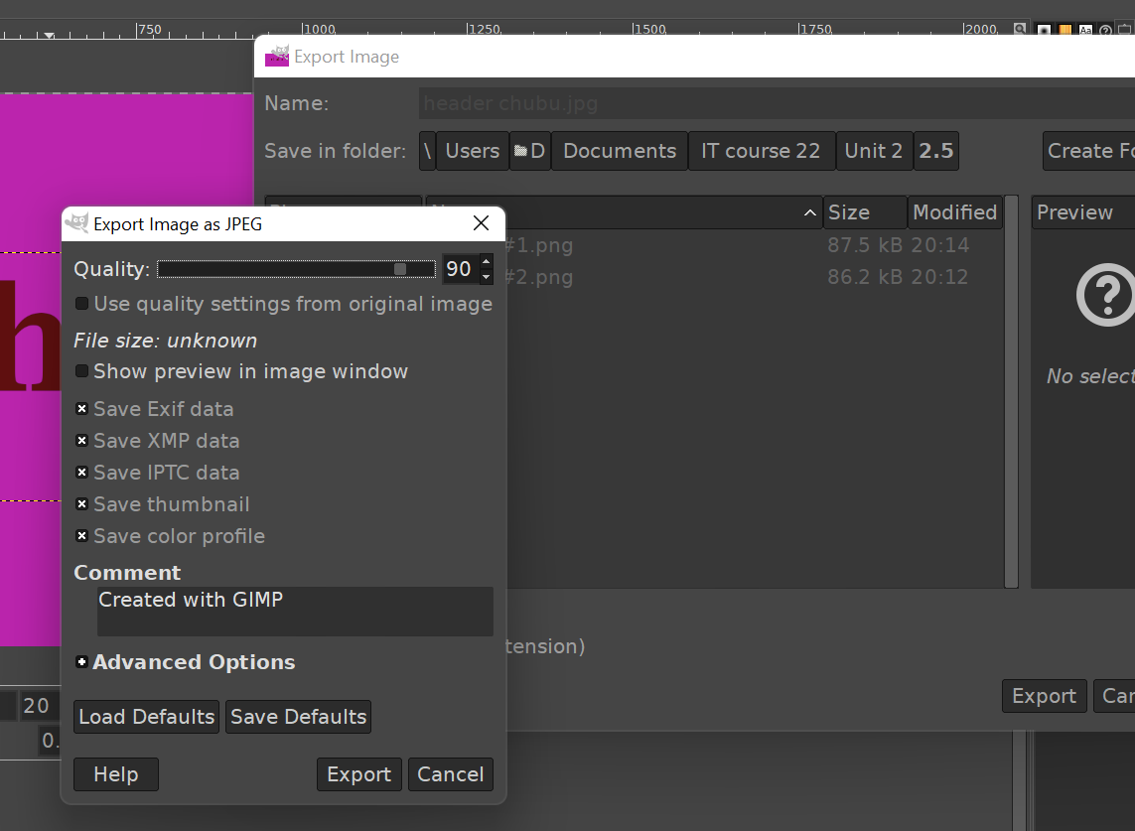

[The above image shows that I have left the export settings the same and just exported it at 90% quality]

I kept the quality high so I could resize it a later date and it won’t lose it’s quality even more if I did or distort if I need to up-scale.

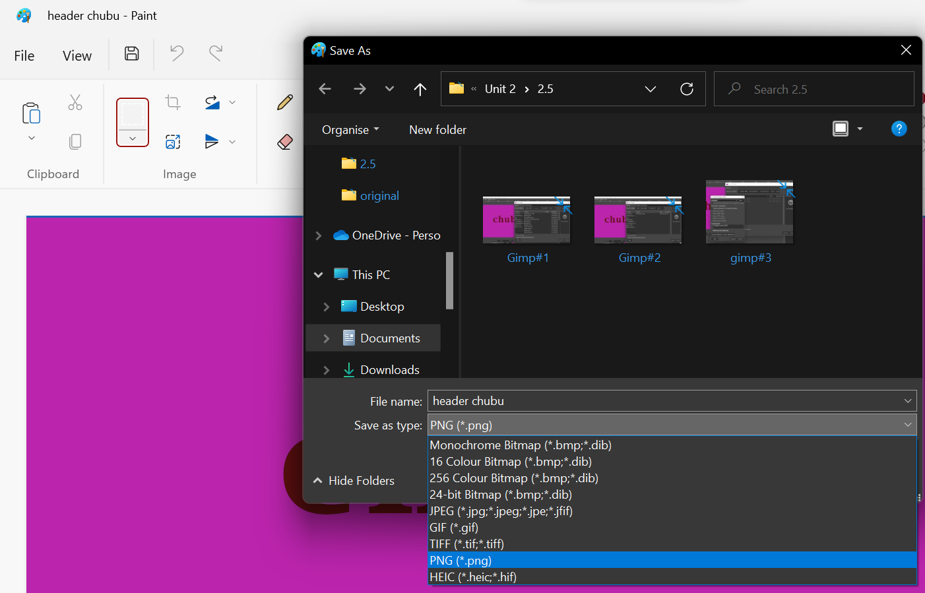

[The above image shows that Paint offers an easier way to save the image in different file extensions]

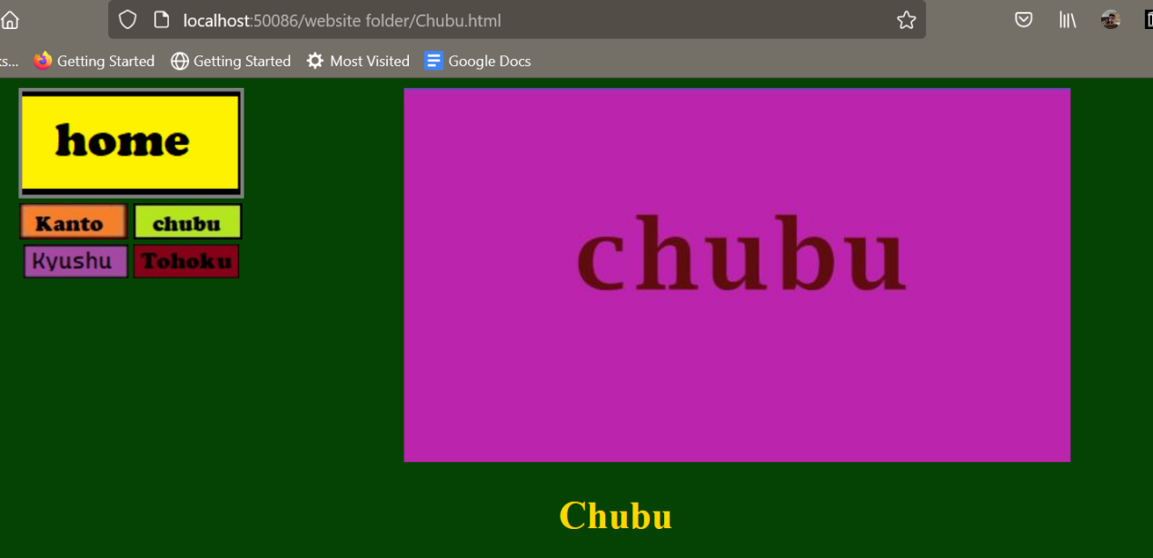

[This is the image on my website]